Configure The Mobile App for Controlling Motor Using Buttons

|  |  |
| --- | --- |
| **Team ID** | **PNT2022TMID08806** |
| **Project Name** | **Hazardous Area Monitoring for Industrial Plant powered by IoT.** |

App Blocks to render the values and display it in app

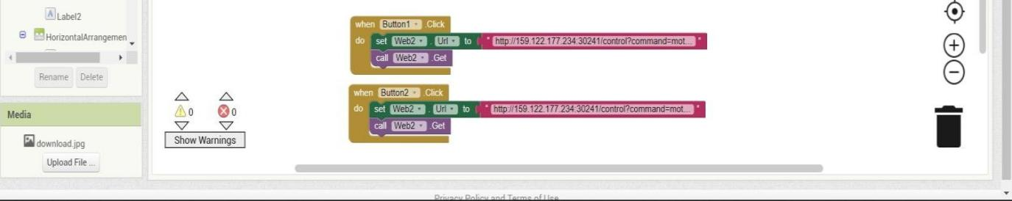

Python block that changes the state of motor based on input from app

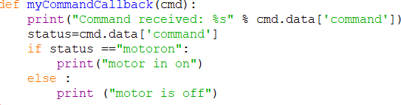

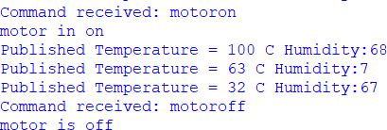Output window